**Recommendation regarding the pricing strategy and facility changes for Big Mountain Resort (August 24, 2021)**

The executives of Big Mountain Resort aim to improve the revenue and profit of the resort in the next season. They have requested an investigation in two broad areas: (1) the optimality of the current ticket price with respect to other resorts in the U.S., and (2) implementation of changes to the facility that lead to cost reduction and revenue improvement. To answer these questions, a machine learning (ML) model was developed based on the data of other resorts within the U.S. The dataset contains information about the location, facility characteristics, and ticket price. Thus, the predictive capability of the ML model is solely limited to these types of features.

Based on the characteristics of Big Mountain Resort, our ML model recommends a ticket price of $94, which is 16% higher than the current ticket price of $81. Two aspects of this result should be taken into account when making a decision. Firstly, the mean absolute error of the model is approximately $10. Secondly, the prices of other resorts within the dataset could also be sub-optimal. To confirm that the Big Mountain Resort is currently underpriced, we investigate the most critical features and compare its standing versus other resorts. A few examples of these features are shown in **Figure 1**. Our data demonstrate that the Big Mountain Resort has one of the best facilities in the nation and is currently priced too low.

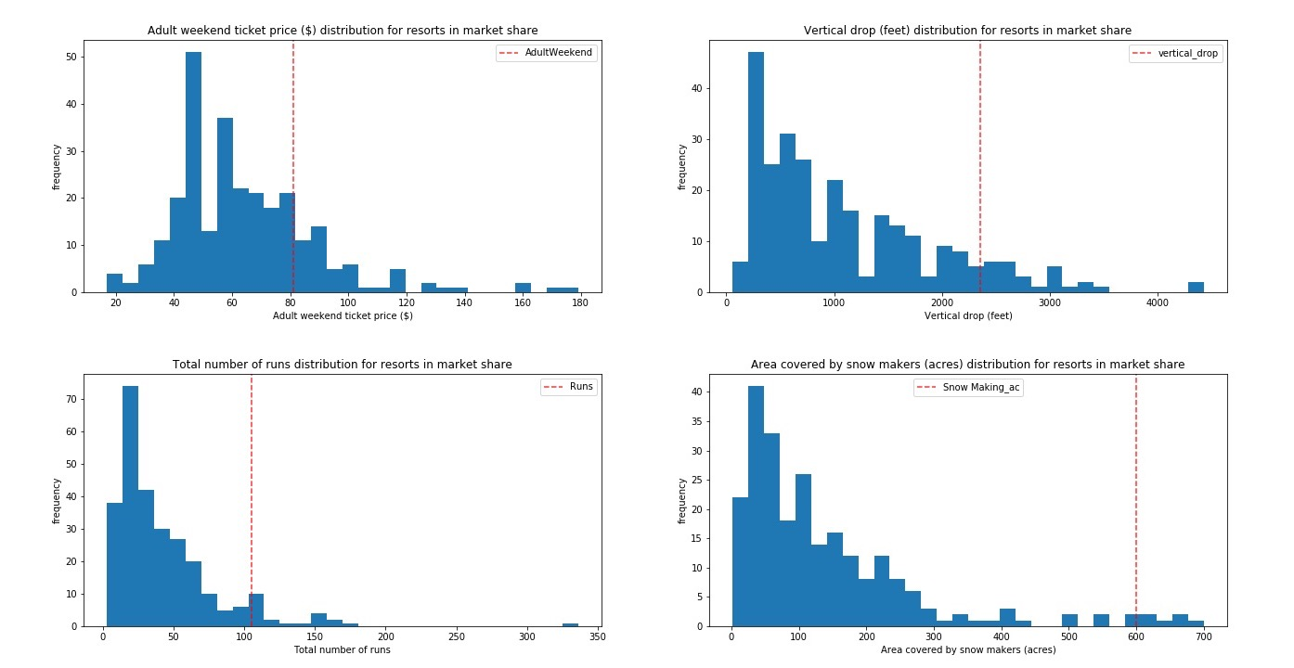

***Figure 1****. (top left) adult weekend ticket price distribution, (top right) vertical drop distribution (bottom left), total number of runs distribution, and (bottom right) area covered by snow makers distribution for resorts in market share. The standing of Big Mountain Resort is indicated by the red dash lines.*

In terms of changes to the facility, four scenarios of implementations were proposed by the business team. From our analysis, we found that the second scenario is the right path forward. The changes should include adding a run that increases the vertical drop by 150 feet, which will require a new chair lift. With this scenario, the ticket price can be increased by $2, adding another $3.5M to the revenue. The revenue calculation was based on 350K visitors for the season where each visitor skis for five days and does not account for additional costs for the new chair lift.